UE20CS301 DBMS LAB

GAURAV MAHAJAN SEC C

LAB 3 DDL COMMANDS

**Create tables for the Above-mentioned Relational design and add check, default, not null and unique constraints.**

**1)Specify PK and FK constraints for all applicable Relations**

**2)For Train_name, Train_Type in Train table add not null constraints**

**value**

**3) Add default constraint for compartment table setting Availability attribute to Yes**

**4)train name should be unique**

**5)Add check constraints to Ticket to check if the passenger age is above 5**

**6)Rename any existing table name**

**7) use Truncate and drop commands**

CREATING THE DATABASE

create database PES1UG20CS150_RR;

use PES1UG20CS150_RR;

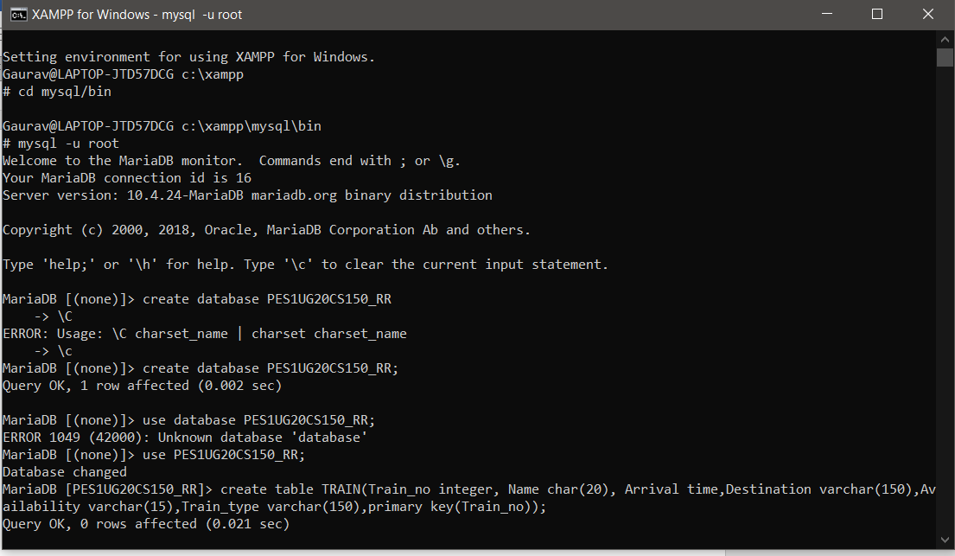

create table TRAIN(Train_no integer not null, Name char(20) not null unique, Arrival time,Destination varchar(150),Availability varchar(15) default 'Yes',Train_type varchar(150) not null,primary key(Train_no));

desc TRAIN;

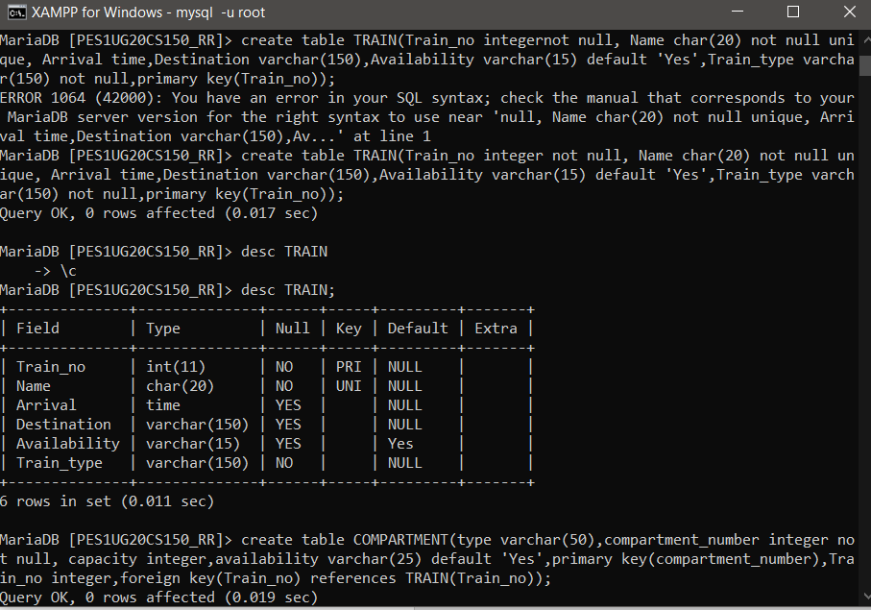

MariaDB [PES1UG20CS150_RR]> create table COMPARTMENT(type varchar(50),compartment_number integer not null, capacity integer,availability varchar(25) default 'Yes',primary key(compartment_number),Train_no integer,foreign key(Train_no) references TRAIN(Train_no));

desc COMPARTMENT;

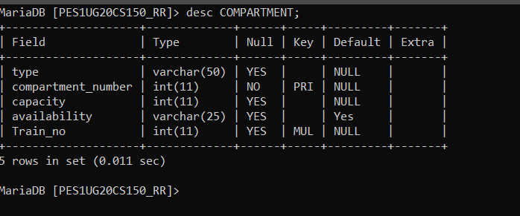

create table ROUTE_INFO(From_Station_No integer,From_Station_Name varchar(100),To_Station_No integer,To_Station_Name varchar(100),Distance varchar(50) ,Train_no integer,primary key(From_Station_No,To_Station_No),foreign key(Train_no) references TRAIN(Train_no));

desc ROUTE_INFO;

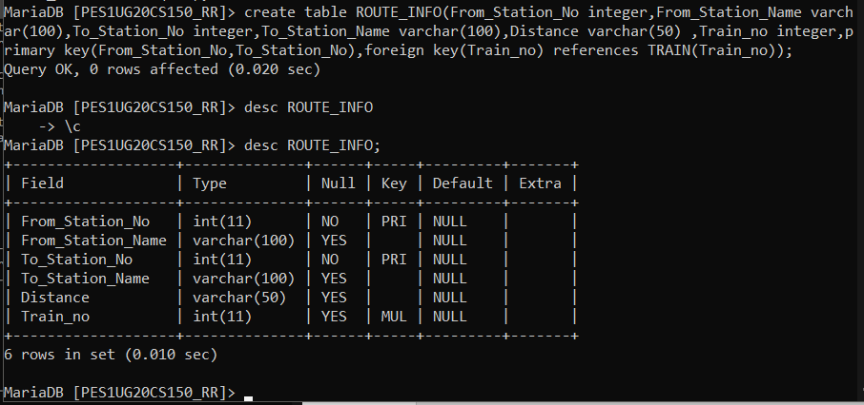

create table USER(User_id integer not null,User_type varchar(100),F_name varchar(100),L_Name varchar(100), Age integer, DOB Date, Pincode integer, Street_no integer,primary key(User_id));

desc USER;

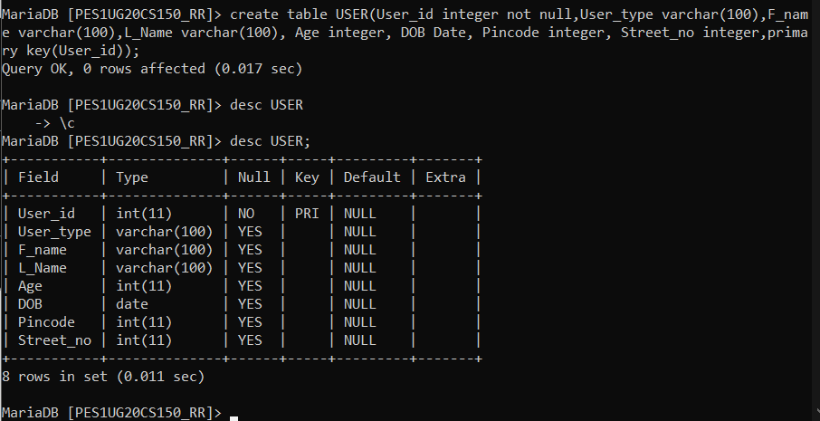

create table TRAIN_USER(Train_No integer,User_id integer,Date_Time_Stamp datetime,primary key(Train_No,User_id,Date_Time_Stamp), foreign key(Train_no) references TRAIN(Train_no),foreign key(User_id) references USER(User_id));

desc TRAIN_USER;

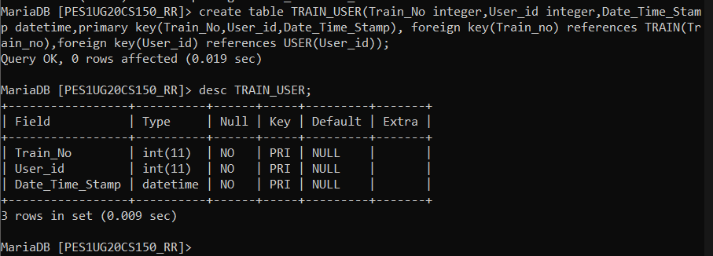

create table USER_PHONE(User_id integer,Phone_no varchar(20),primary key(User_id,Phone_no), foreign key(User_id) references USER(User_id));

desc USER_PHONE;

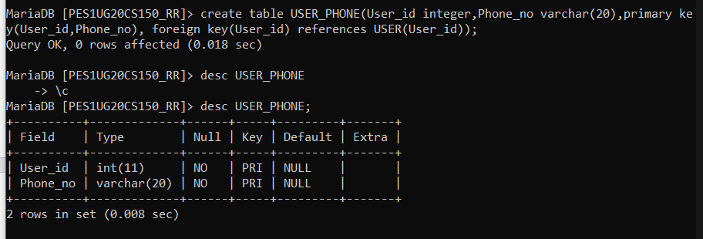

create table TICKET(PNR integer,primary key(PNR),Train_NUmber integer,travel_date date, Departure varchar(100),Arrival varchar(100),Departure_time time,Arrival_Time time,User_id integer, Train_type varchar(20),Compartment_type varchar(20), Cmpt_No integer, foreign key(User_id) references USER(User_id));

desc TICKET;

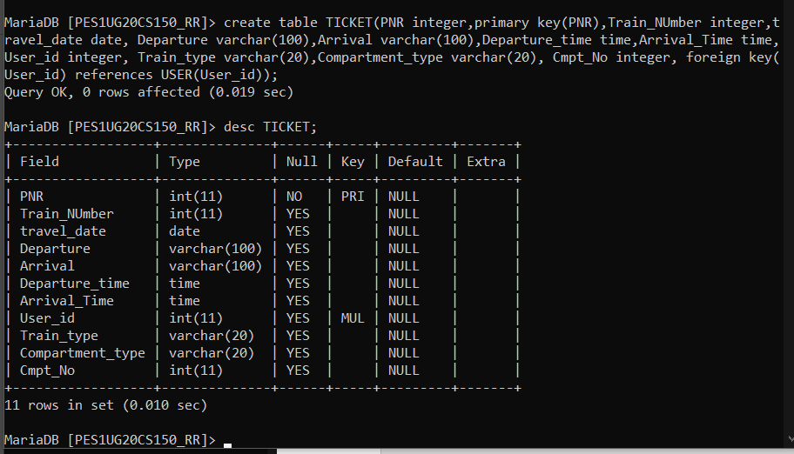

create table PAYMENT_INFO(Transaction_id integer,primary key(Transaction_id),Bank varchar(100), Card_Number integer,Price integer, PNR integer, foreign key(PNR) references TICKET(PNR));

desc PAYMENT_INFO;

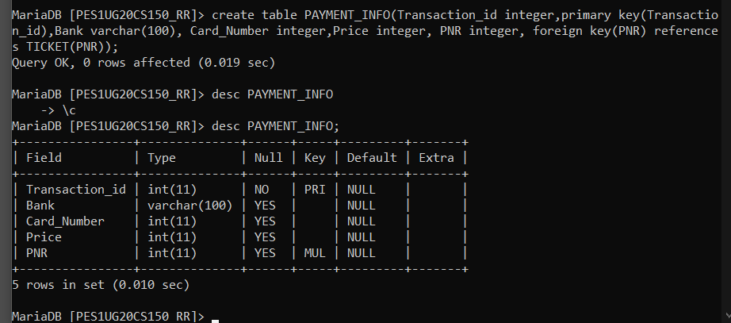

create table TICKET_PASSENGER(Seat_No integer, primary key(Seat_No),Name varchar(20),Age integer, PNR integer, foreign key(PNR) references TICKET(PNR));

desc TICKET_PASSENGER;

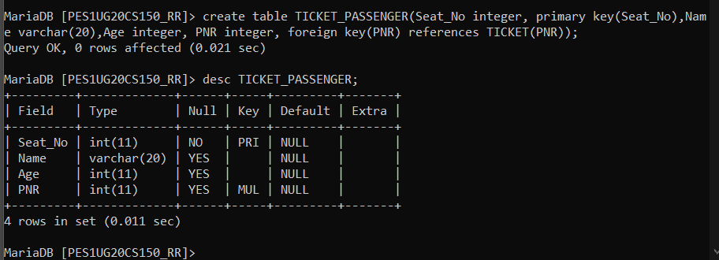

create table FARE_TABLE(Train_type varchar(100),Compartment_type varchar(100),primary key(Train_type,Compartment_type), FareperKM integer);

desc FARE_TABLE;

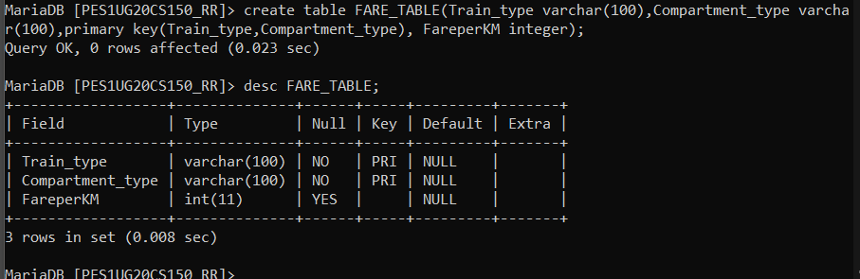

alter table TICKET_PASSENGER add check(Age>5);

desc TICKET_PASSENGER;

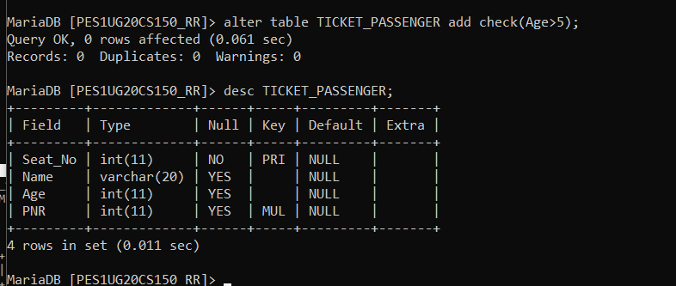

alter table FARE_TABLE rename FARE;

desc FARE_TABLE;

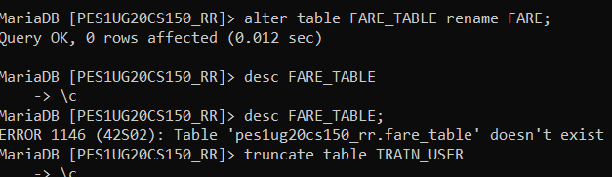

truncate table TRAIN_USER;

desc TRAIN_USER;

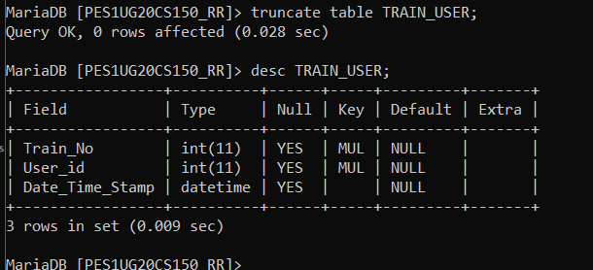

drop table TRAIN_USER;

desc TRAIN_USER;

